**COMPUTER SCIENCE PROJECT CPSC - 597**

**BALANCING PERFORMANCE, ACCURACY AND PRECISION FOR SECURE CLOUD TRANSACTIONS**



**Final Report**

**Report by: -**

Bhargav Krishna Lavu

802373670**|** Bhargavkrishnaa@csu.fullerton.edu

**Project Advisor:** Dr. Shawn X Wang

**Project Reviewer:** Prof. Bin Cong

Department of Computer Science

California State University, Fullerton

Spring 2016

Table of Contents

**Abstract** 5

**1.** **Introduction** 6

**1.1.** **What is cloud computing?** 6

**1.2.** **How Cloud Computing Works?** 7

**1.3.** **Qualities(Characteristics) and Services Models** 7

**1.3.1.** **On-request self-benefit** 7

**1.3.2.** **Broad system access** 8

**1.3.3.** **Resource pooling** 8

**1.3.4.** **Rapid flexibility** 8

**1.3.5.** **Measured administration** 8

**1.4.** **Characteristics of Cloud Computing** 9

**1.5.** **Services Models** 10

**1.5.1.** **Benefits of cloud computing** 11

**1.5.2.** **Advantages** 12

**2.** **Requirements** 13

**2.1.** **System Requirements** 13

**2.1.1.** **Hardware Requirements** 13

**2.1.2.** **Software Requirements** 13

**3.** **Specification** 14

**3.1.** **Data Flow Diagram** 14

**3.2.** **UML Diagrams** 16

**3.2.1.** **Use Case Diagram** 17

**3.2.2.** **Class Diagram** 19

**3.2.3.** **Sequence Diagram** 21

**3.2.4.** **Activity Diagram** 23

**4.** **Design** 25

**4.1.** **Input Design** 25

**4.2.** **Objectives** 25

**4.3.** **Output Design** 26

**5.** **Implementation** 27

**5.1.** **Modules** 27

**5.2.** **Modules Description** 27

**5.2.1.** **Server Model** 27

**5.2.2.** **Cloud User Module** 28

**5.2.3.** **Transaction Manager** 28

**5.2.4.** **Certificate Authorities (Cloud Admin)** 29

**6.** **Testing** 30

**6.1.** **System Testing** 30

**6.2.** **Types of Testing** 30

**6.2.1.** **Unit Testing** 30

**6.2.2.** **Integration testing** 31

**6.2.3.** **Functional testing** 31

**6.3.** **System Testing** 32

**6.3.1.** **White Box Testing** 32

**6.3.2.** **Black Box Testing** 32

**6.3.3.** **Unit Testing** 33

**6.3.4.** **Integration Testing** 34

**6.3.5.** **Acceptance Testing** 34

**7.** **User Manual** 35

**8.** **Conclusion** 64

**9.** **Bibliography** 65

**10.** **Appendix** 69

**Acknowledgement**

It’s my pleasure to confess the immense motivation and strength given to me by **Professor Dr. Shawn X Wang**, my project class tutor. In spite of his hectic schedule he has guided me in an appropriate manner which made me to accomplish the task with a good result. I was able to master the project in all the aspects under your supervision. His efforts towards helping me in my work even in his busy schedules are highly appreciated. I would also like to thank **Professor Bin Cong,** reviewer of project for his interest in initiating and supporting me.

Yours Sincerely

Bhargav Krishna Lavu

# **Abstract**

In distributed transactional database systems deployed over cloud servers, entities cooperate to form proofs of authorizations that are justified by collections of certified credentials. These proofs and credentials may be evaluated and collected over extended time periods under the risk of having the underlying authorization policies or the user credentials being in inconsistent states. It therefore becomes possible for policy-based authorization systems to make unsafe decisions that might threaten sensitive resources. In this paper, we highlight the criticality of the problem. We then define the notion of trusted transactions when dealing with proofs of authorization. Accordingly, we propose several increasingly stringent levels of policy consistency constraints, and present different enforcement approaches to guarantee the trustworthiness of transactions executing on cloud servers. We propose a Two-Phase Validation Commit protocol as a solution, which is a modified version of the basic Two-Phase Validation Commit protocols. We finally analyse the different approaches presented using both analytical evaluation of the overheads and simulations to guide the decision makers to which approach to use.

# **Introduction**

## **What is cloud computing?**

**Cloud computing** is the use of computer related resources either hardware and software that are delivered as a service over a network (typically the [Internet](http://en.wikipedia.org/wiki/Internet)). The name comes from the common use of a cloud-shaped symbol as an abstraction for the complex infrastructure it contains in system diagrams. Cloud computing entrusts remote services with a user's data, software and computation. Cloud computing consists of hardware and software resources made available on the Internet as managed third-party services. These services typically provide access to advanced software applications and high-end networks of server computers.

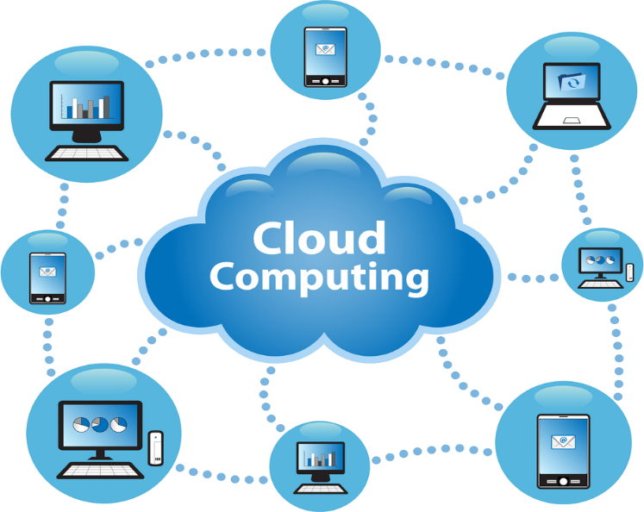

Structure of Cloud Computing

## **How Cloud Computing Works?**

The objective of cloud computing is to apply conventional supercomputing, or superior registering power, it is heavily used by military and other related offices, to perform millions of calculations every second, in customer situated applications, for example, money related profiles, to regard modified data, to give information stacking or to influence substantial, immense PC diversions.

The cloud computing uses systems of large gatherings of servers commonly running minimal effort purchaser PC innovation with specific associations with spread information handling works crosswise over them. Frequently, virtualization methods are utilized to expand the force of distributed computing.

## **Qualities(Characteristics) and Services Models**

The striking qualities of distributed computing in light of the definitions gave by the National Institute of Standards and Terminology are laid out underneath



### **On-request self-benefit**

A shopper can singularly procurement figuring capacities, for example, server time and system stacking, as required naturally without requiring human interaction with every administration's supplier.

### **Broad system access**

Capabilities are viewable over the system and got to through standard instruments that advance use by heterogeneous dainty or thick customer stages.

### **Resource pooling**

The supplier's registering assets are pooled to serve various shoppers utilizing a multi-inhabitant model, with various physical and virtual assets powerfully allocated and reassigned by interest. There is a feeling of area autonomy in that the client for the most part has no control or learning over the careful area of the gave assets however might have the capacity to determine area at a more elevated amount of deliberation (e.g., nation, state, or server farm). Case of assets incorporate stockpiling, handling, memory, system data transmission, and virtual machines.

### **Rapid flexibility**

value can be quickly and flexibly entitled, at times naturally, to rapidly scale out and quickly discharge to rapidly scale in. To the shopper, the abilities accessible for provisioning regularly have all the earmarks of being boundless.

### **Measured administration**

Cloud frameworks simultaneously control and streamline asset use by utilizing a measure capacity at some level of reflection suitable to the kind of administration. Asset utilization can be overseen, controlled, and reported giving straightforwardness to both the supplier and buyer of the used administration.

## **Characteristics of Cloud Computing**

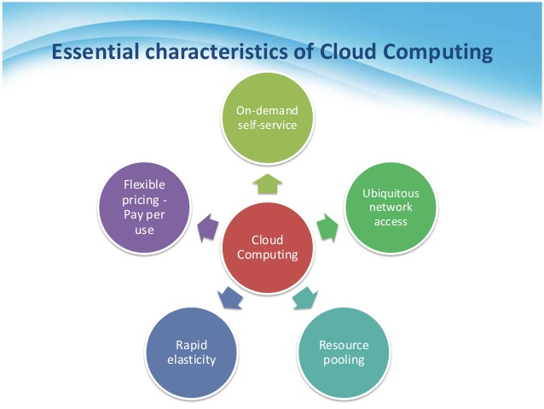

Characteristics of Cloud Computing

## **Services Models**

  Cloud Computing comprises of three diverse administration models, to be specific Infrastructure-as-a-Service, Platform-as-a-Service, and Software-as-a-Service. The three administration models or layer are finished by an end client layer that embodies the end client point of view on cloud administrations. The model is appeared in figure beneath. On the off chance that a cloud client gets to administrations on the framework layer, for occurrence, it can run its own applications on the assets of a cloud foundation and stay in charge of the support, maintenance, and security of these applications herself. On the off chance that she gets to the service on the application layer, these assignments are ordinarily dealt with by the cloud service provider.

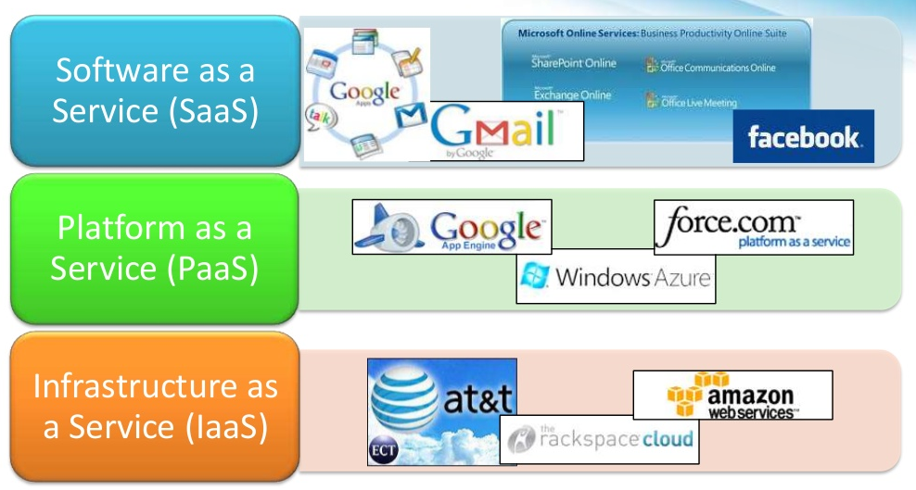

Structure of Service Models



### **Benefits of cloud computing**

1. Build volume yield or efficiency with less individuals. Your expense per unit, undertaking or item plunges.
2. Keep up simple access to your data with less spending. Pay as you go (week, quarterly or yearly), in view of interest.
3. People worldwide can access the cloud, provided they have an Internet connection.
4. Get more work done in less time with less people.
5. There’s no need to spend big money on hardware, software or licensing fees.
6. You have access anytime, anywhere, making your life so much easier!
7. Stay within budget and ahead of completion cycle times.
8. It takes fewer people to do more work on a cloud, with a minimal learning curve on hardware and software issues.
9. Stretch and grow without the need to buy expensive software licenses or programs.
10. You can change direction without serious “people” or “financial” issues at stake.

### **Advantages**

1. **Price:** Pay for only the resources utilized.
2. **Security**: Cloud occasions are detached in the system from different occurrences for enhanced security.
3. **Performance**: Instances can be included immediately for enhanced execution. Customers have admittance to the aggregate assets of the Cloud's center equipment.
4. **Scalability**: Auto-send cloud occasions when required.
5. **Uptime**: Uses various servers for most extreme redundancies. If there should be an occurrence of server disappointment, occasions can be consequently made on another server.
6. **Control**: Able to login from any area. Server preview and a product library gives you a chance to convey custom cases.
7. **Traffic**: Deals with spike in movement with speedy arrangement of extra occasions to handle the heap.

# **Requirements**



## **System Requirements**



### **Hardware Requirements**

* System : Pentium IV 2.4 GHz.
* Hard Disk : 40 GB.
* Floppy Drive : 1.44 Mb.
* Monitor : 15 VGA Colour.
* Mouse : Logitech.
* Ram : 512 Mb.

### **Software Requirements**

* Operating system : Windows XP/7.
* Coding Language : ASP.net, C#.net
* Tool : Visual Studio 2010 or Latest
* Database : SQL SERVER 2008 or Latest

# **Specification**



## **Data Flow Diagram**

1. The DFD is likewise called as bubble outline. It is a straightforward graphical formalism that can be utilized to speak to a framework regarding info information to the framework, different preparing did on this information, and the yield information is created by this framework.

2. The information stream outline (DFD) is a standout amongst the most vital demonstrating devices. It is utilized to display the framework parts. These segments are the framework procedure, the information utilized by the procedure, an outside substance that connects with the framework and the data streams in the framework.

3. DFD shows how the data travels through the framework and how it is adjusted by a progression of changes. It is a graphical system that delineates data stream and the changes that are connected as information moves from contribution to yield.

4. DFD is otherwise called bubble outline. A DFD might be utilized to speak to a framework at any level of reflection. DFD might be divided into levels that speak to expanding data stream and utilitarian subtle element.



Data Flow Diagram

## **UML Diagrams**

UML remains for Unified Modeling Language. UML is an institutionalized universally useful displaying dialect in the field of article situated programming building. The standard is overseen, and was made by, the Object Management Group.

The objective is for UML to end up a typical dialect for making models of article situated PC programming. In its present structure UML is included two noteworthy parts: a Meta-model and a documentation. Later on, some type of technique or procedure may likewise be added to; or connected with, UML.

The Unified Modeling Language is a standard dialect for determining, Visualization, Constructing and recording the ancient rarities of programming framework, and in addition for business demonstrating and other non-programming frameworks.

The UML speaks to a gathering of best building hones that have demonstrated fruitful in the displaying of vast and complex frameworks.

The UML is a critical piece of creating articles arranged programming and the product advancement process. The UML utilizes generally graphical documentations to express the outline of programming activities.

**Objectives**

The Primary objectives in the outline of the UML are as per the following:

1. Provide clients a prepared to-use, expressive visual displaying Language with the goal that they can create and trade important models.

2. Provide extendibility and specialization systems to develop the center ideas.

3. Be free of specific programming dialects and improvement process.

4. Provide a formal premise for comprehension the displaying dialect.

5. Encourage the development of OO instruments market.

6. Support more elevated amount advancement ideas, for example, coordinated efforts, structures, examples and segments.

7. Integrate best practices.



### **Use Case Diagram**

A use case diagram in the Unified Modeling Language (UML) is a sort of behavioral chart characterized by and made from a Use-case investigation. Its motivation is to exhibit a graphical diagram of the usefulness gave by a framework as far as on-screen characters, their objectives (spoke to as use cases), and any conditions between those utilization cases. The primary reason for a use case diagram is to show what framework capacities are performed for which actor. Roles of actors in the framework can be portrayed.

Advantage of use case views are:

1.Show in one diagram how bigger activities/use cases are made out of littler ones, utilizing the Includes connection.

2.Associate every activity/use case unequivocally to the clients or outer frameworks required in its execution.

3.Draw limits around the activities/use cases bolstered by your framework, or every significant segment of it.



Use Case Diagram

### **Class Diagram**

In software engineering, in programming building, a class diagram in the Unified Modeling Language is a kind of static structure diagram that depicts the structure of a framework by demonstrating the framework's classes, their characteristics, operations (or strategies), and the connections among the classes. It clarifies which class contains data.



Class Diagram

### **Sequence Diagram**

A sequence diagram in Unified Modeling Language is a sort of collaboration diagram that shows how forms work with each other and in what request. It is a build of a Message Sequence Chart.

In sequence diagram, the user sends the request and gets the response in the form of messages. The time frame is also calculated here as we have the time line or life line to show when the request is sent and the response is given back.



Sequence Diagram

### **Activity Diagram**

Activity diagrams are graphical representations of work processes of stepwise exercises and activities with backing for decision, emphasis and simultaneousness. In the Unified Modeling Language, activity diagrams can be utilized to depict the business and operational regulated work processes of segments in a framework. It usually demonstrates the general stream of control.

We have different bars as notations in this diagram such as decisions are represented in diamond box. The initial and end points are also shown with circle. There are horizontal and vertical synchronization bars and each of them are used respectively depending on the situation.



Activity Diagram

# **Design**



## **Input Design**

Input design plays a vital role in connecting the information system and the user. The initial process of developing an input design involves gathering specifications and creating procedures for data preparation. These steps are essential in transforming transactional data in to a usable form which can be achieved by feeding data from a document by scanning it or by manually entering it in to a computer system. Controlling the amount of input data flow, minimizing the errors, achieving time efficiency and keeping the process as simple as possible to avoid complexity are few key constraints that are considered before developing an input design. Security measures were taken in order to maintain privacy of the user data.

Input Design is developed by focusing on the following aspects:

* What type of data must be given as input?
* How to avoid data redundancy?
* The input providing guide to the operating facilitator.
* New equations for validating inputs and guide to follow when error appears.

## **Objectives**

1. The process of transforming a user-oriented description of the input into a computer based system is called an Input design. This is to ensure there are no errors in the input data flow and to guide the management to acquire an effective and efficient information from computerized system.

2. This can be achieved by creating user friendly graphic interfaces to upload huge volumes of data. The goal of designing input is to achieve an edge over data by extracting error-free valuable information. These user interfaces can be easily used to perform various operations on data like record viewing and manipulating data.

3. Data validations are created to ensure and maintain data consistency. Data can be easily entered in to system by using the GUI’s and appropriate messages are provided to the user to avoid confusion.

## **Output Design**

The Quality of an output is measured by assessing if it is meeting all the business objectives of the end user and also the information it is presenting is clear and concise. In any system the outcomes of a process are delivered to the users and other internal systems through outputs. Intelligent and efficient output design improves the system’s ability to assist the user in decision-making.

1. Designing a computer output should be carried out in a well organize way.

2. Select methods to present information.

3. Create a report document that contains information extracted from the system.

The desired output should be able to represent the following objectives.

* Should be able to provide information to the end user about the current/future state.
* Report problems by creating warnings, Give updates about important events and opportunities.
* Should be able to create/trigger an action.

# **Implementation**



## **Modules**

1. Server Module.
2. Cloud User Module.
3. Transaction Manager.
4. Certificate Authorities or Cloud Admin.

## **Modules Description**



### **Server Model**

In this Module, we design a cloud infrastructure consisting of a set of servers, where each server is responsible for hosting a subset of all data items belonging to a specific application domain.

### **Cloud User Module**

* In this Module, Users interact with the system by submitting queries or update requests encapsulated in ACID transactions.
* Since transactions are executed over time, the state information of the credentials and the policies enforced by different servers are subject to changes at any time instance, therefore it becomes important to introduce precise definitions for the different consistency levels that could be achieved within a transaction’s lifetime. These consistency models strengthen the trusted transaction definition by defining the environment in which policy versions are consistent relative to the rest of the system. Before we do that, we define a transaction’s view in terms of the different proofs of authorization evaluated during the lifetime of a particular transaction.

### **Transaction Manager**

* A transaction is submitted to a Transaction Manager(TM) that coordinates its execution. Multiple TMs could be invoked as the system workload increases for load balancing, but each transaction is handled by only one TM.
* A common characteristic of most of our proposed approaches to achieve trusted transactions is the need for policy consistency validation at the end of a transaction. That is, in order for a trusted transaction to commit, its TM has to enforce either view or global consistency among the servers participating in the transaction.

### **Certificate Authorities (Cloud Admin)**

* There will be a set of policies from which a cloud user can choose. He can choose one or all of it or a few according to his convenience.
* A safe transaction will be provided. A safe transaction is a transaction that is both trusted (i.e., satisfies the correctness properties of proofs of authorization) and database correct (i.e., satisfies the data integrity constraints).
* In this module, also develop Two Phase Validation system. As the name implies, 2PV operates in two phases: collection and validation. During collection, the TM first sends a Prepare-to-Validate message to each participant server. In response to this message, each participant 1) evaluates the proofs for each query of the transaction using the latest policies it has available and 2) sends a reply back to the TM containing the truth value (TRUE/FALSE) of those proofs along with the version number and policy identifier for each policy used.

# **Testing**



## **System Testing**

The reason for testing is to find errors. Trying is the methodology about attempting on find each possible shortcoming or shortcoming clinched alongside a fill in item. It gives an approach should weigh those purpose from claiming components, sub-assemblies, assemblies or An done item it is those methodology for working out programming for those purpose of guaranteeing that the programming framework meets its necessities Furthermore client desires Also doesn't neglect Previously, an unsuitability way. There would different sorts for test. Each test kind addresses a particular testing prerequisite.

## **Types of Testing**



### **Unit Testing**

Unit testing includes the plan about test situations that accept that the internal project logic is working properly, also that project inputs prepare substantial outputs. The sum choice extensions Furthermore interior code stream ought to make approved. It is those trying from claiming individual programming units of the provision. It will be completed after those fruitions about a distinct unit in front of coordination. This may be a structural testing, that depends ahead learning for its development Furthermore is obtrusive. Unit tests perform fundamental tests In part level and test a particular business process, application, or framework setup. Unit tests guarantee that every interesting way of a benefits of the business methodology performs faultlessly of the recorded determinations What's more holds obviously characterized inputs What's more relied upon comes about.

### **Integration testing**

Coordination tests need aid intended will test coordinated circuit programming segments should figure out whether they really run Similarly as you quit offering on that one system. Testing may be occasion driven Also will be that's only the tip of the iceberg concerned with the fundamental result of screens or fields. Mix tests show that in spite of those parts were separately satisfaction, as indicated Toward effectively unit testing, the blending from claiming parts is right What's more steady. Coordination trying is particularly pointed toward exposing those issues that emerge from the blending about segments.

### **Functional testing**

Functional tests give exact shows that limits attempted are open as determined Eventually Tom's examining the business Furthermore concentrated foul necessities, structure documentation, Also customer manuals.

Functional testing is fixated on the accompanying things:

Legitimate Input: distinguished classes of substantial info must be acknowledged.

Invalid Input: distinguished classes of invalid info must be rejected.

Capacities: distinguished capacities must be worked out.

Yield : distinguished classes of utilization yields must be worked out.

Frameworks/Procedures: interfacing frameworks or systems must be summoned.

Association and planning of useful tests is centered around prerequisites, key capacities, or unique experiments. What's more, orderly scope relating to distinguish Business process streams; information fields, and progressive procedures considered for testing. Before utilitarian testing is finished, extra tests are distinguished and the powerful estimation of current tests is resolved.

## **System Testing**

System testing ensures that the entire integrated software system meets requirements. It tests a configuration to ensure known and predictable results. An example of system testing is the configuration oriented system integration test. System testing is based on process descriptions and flows, emphasizing pre-driven process links and integration points.



### **White Box Testing**

White Box Testing is a trying in which in which the product analyzer knows about the inward workings, structure, or if nothing else its motivation. It is reason. It is utilized to test zones that can't be come to from a discovery level.

### **Black Box Testing**

Black Box Testing will be trying the product with no information of the internal workings, structure or dialect of the module being tried. Discovery tests, as most different sorts of tests, must be composed from a complete source record, for example, particular or prerequisites report, for example, determination or necessities archive. The test gives inputs and reacts to yields without considering how the product functions.

### **Unit Testing**

Unit testing is typically led as a component of a consolidated code and unit test period of the product lifecycle, in spite of the fact that it is not unprecedented for coding and unit testing to be led as two unmistakable stages.

**Test Strategy and Approach**

Field testing will be performed physically and utilitarian tests will be composed in point of interest.

Test destinations

• All field sections must work appropriately.

• Pages must be initiated from the recognized connection.

• The passage screen, messages and reactions must not be postponed.

Components to be tried

• Verify that the passages are of the right arrangement

• No copy passages ought to be permitted

• All connections ought to take the client to the right page.

### **Integration Testing**

Software integration testing is the incremental incorporation testing of two or more coordinated programming segments on a solitary stage to deliver disappointments created by interface imperfections. The assignment of the combination test is to watch that segments or programming applications, e.g. parts in a product framework or one stage up programming applications at the organization level – interface without mistake.

Test Results: All the experiments said above passed effectively. No deformities experienced.

### **Acceptance Testing**

User Acceptance Testing is a basic period of any undertaking and requires noteworthy investment by the end client. It likewise guarantees that the framework meets the practical necessities.

**Test Results**

All the experiments said above passed effectively. No imperfections experienced.

# **User Manual**

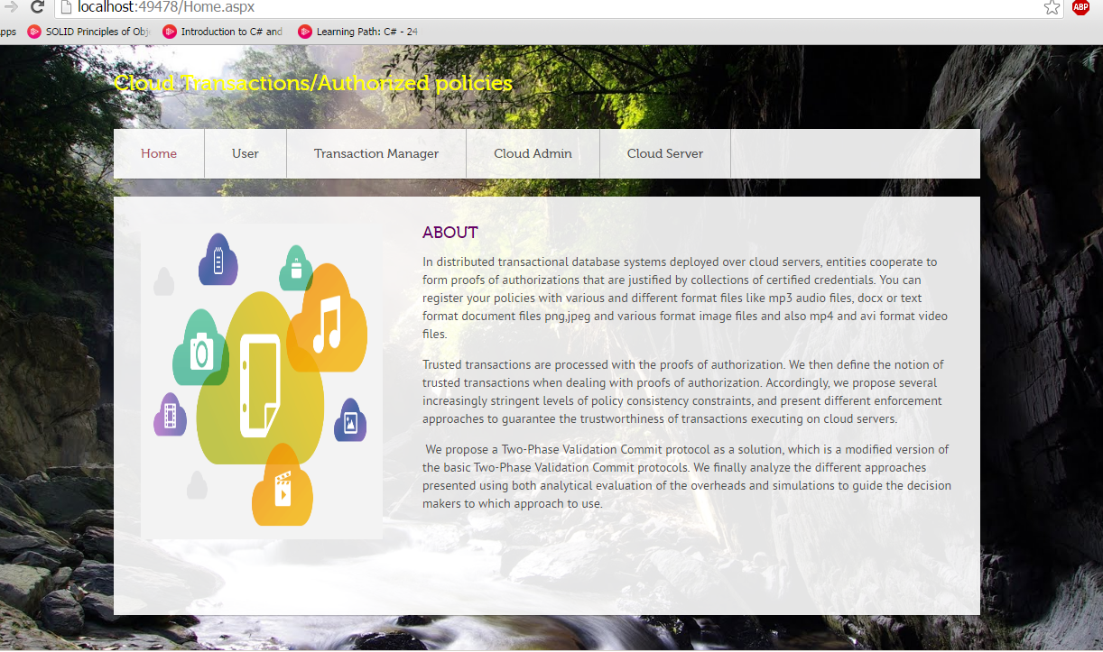

Home Page

First we open visual studio 2013 ultimate version and set the home page c# file as the starter page or start up page. After setting up the startup website page we then go to the build option in the list of tools tab click on the build so that it constructs or builds the total code altogether to form a validation or a valid solution which helps us to locate if there any errors or warnings. The errors or warnings appear on the bottom box which points out the location of the error and what caused the error. So after all the validation and execution we debug the whole page then choose either the internet explorer or google chrome as the web browser. After the browser opens it will connect to the local host which acts as a website link. After connecting to the link the Home about page will open which consists of the info about the website or the functionalities provided in the website. There are multiple background wallpapers which make it easy for the user to relate to as it won’t be plane. When the user is given some good images or some design they feel better while using the website.

* 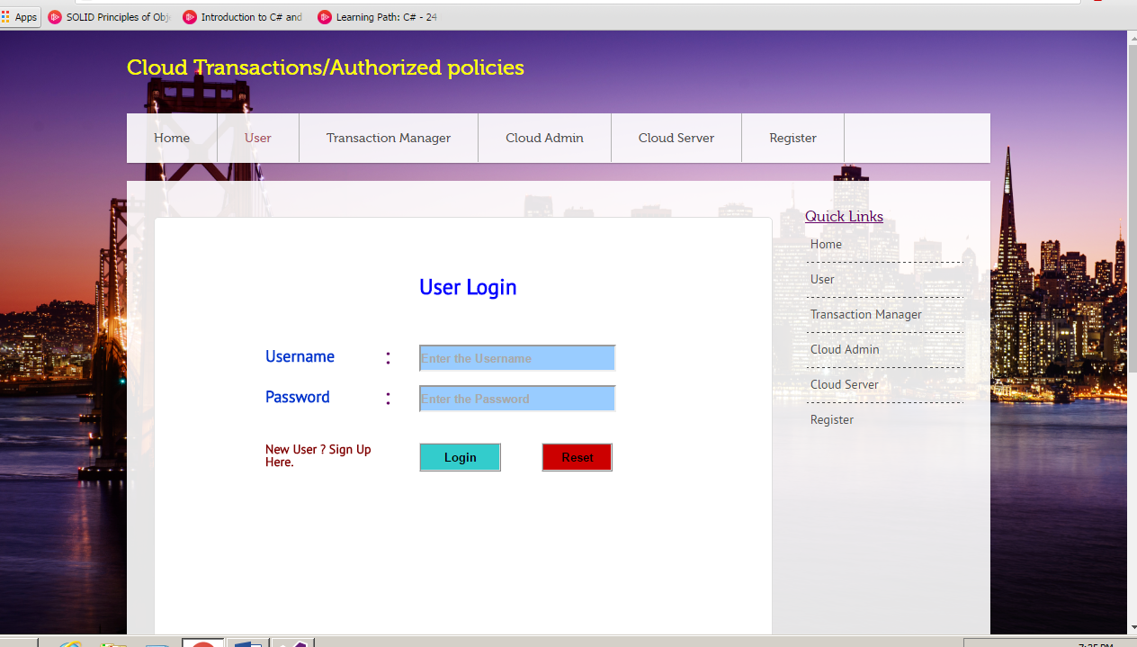

User Login Page

First is the home page, next comes the user login page where already authorized users can login or have access into the website or their page. If it’s a new user, he can use the register link on the right or on the top right. If the old users forget their account, they can always create a new account according to their convenience.

* 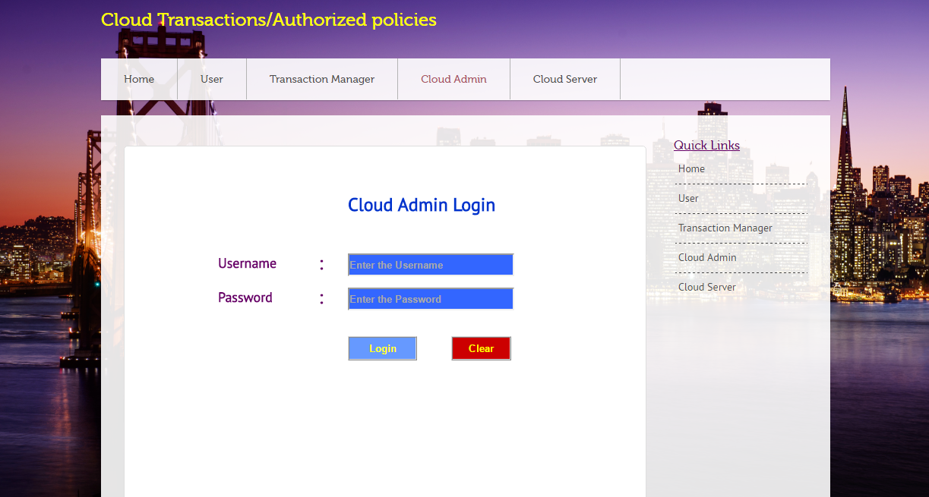

Cloud admin login

Next comes the cloud admin page where the admin logins to give credentials to the new users who are awaiting to be activated and given access permission to. In this website cloud admin does two roles which would be covered and explained in the next coming screen shots.

* 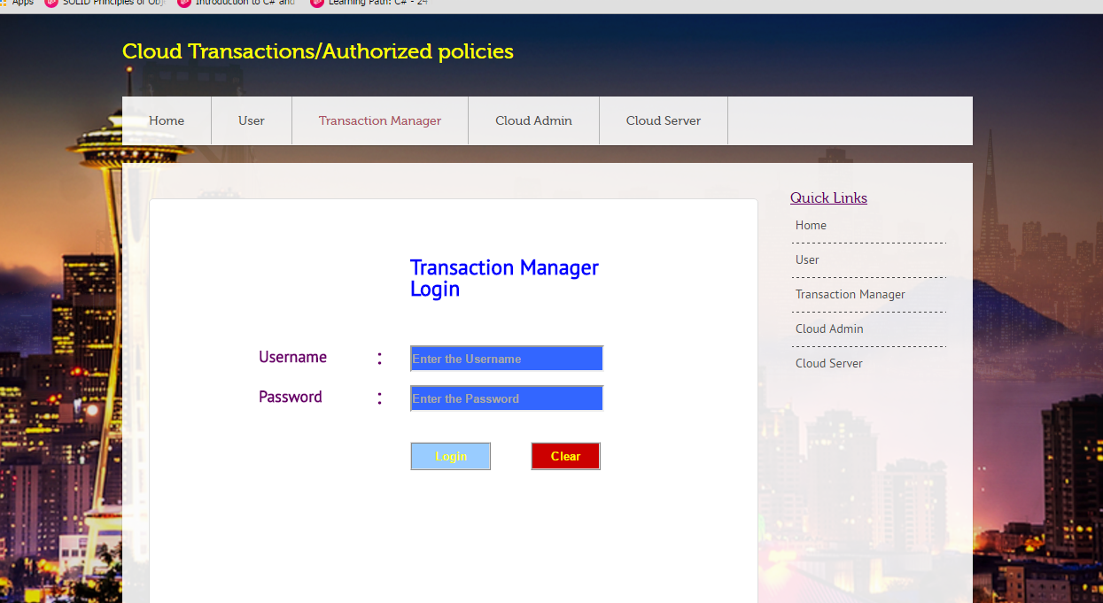

Transaction Manager

This is the transaction manager page where the tm logins to verify and allow the files reviewed by the cloud admin in the cloud server page.

* 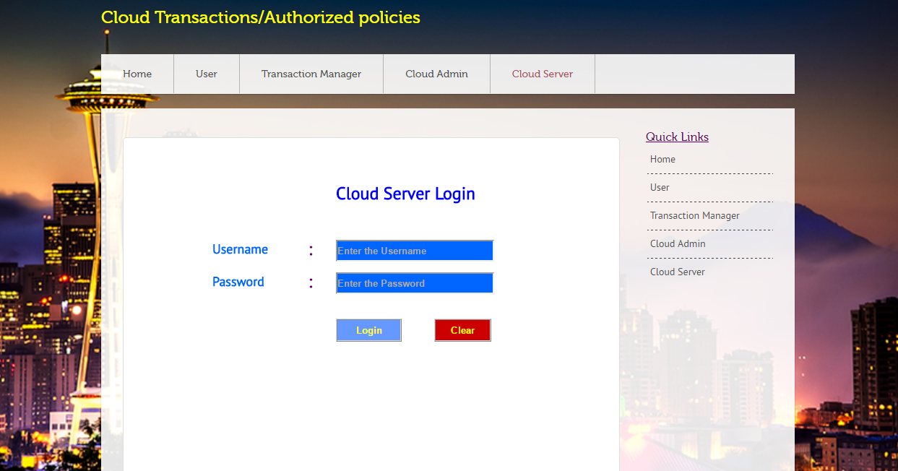

Cloud Server Login

* 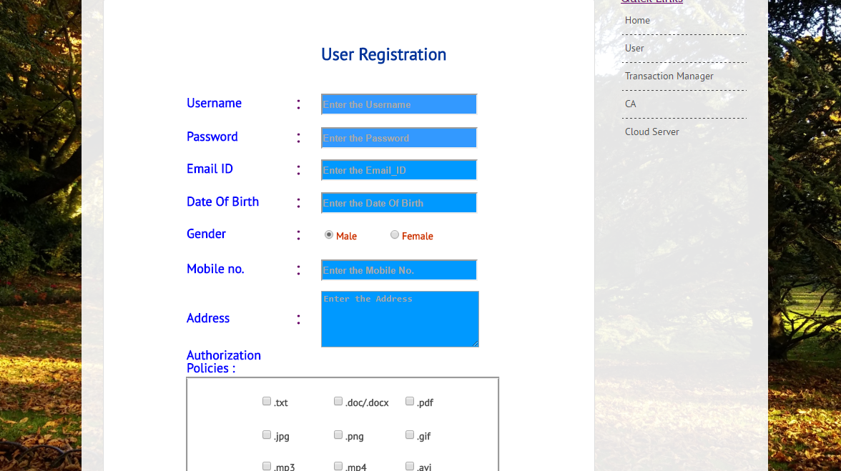

User Registration

* 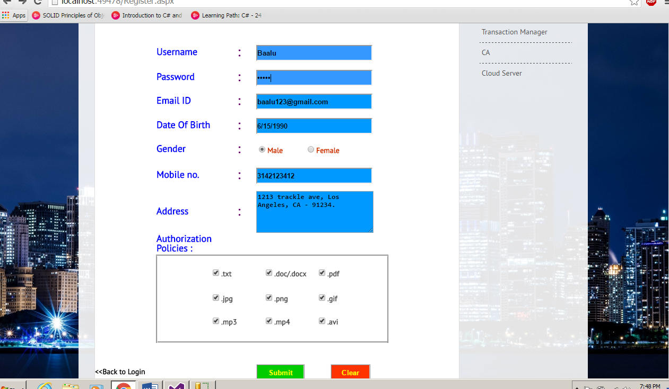

User Registration ii

* 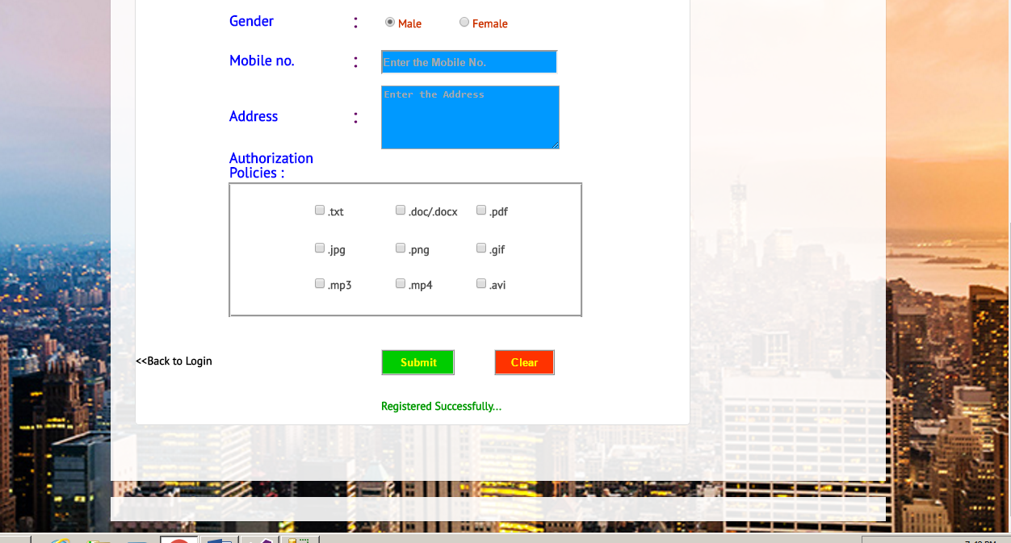

Registered Successfully

* 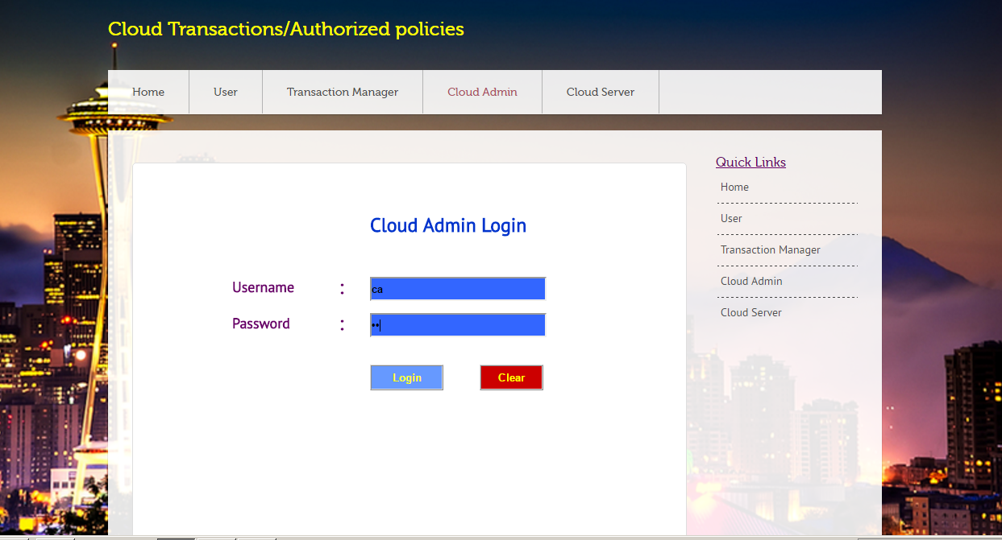

Admin Login into

* 

Cloud Admin Page

* 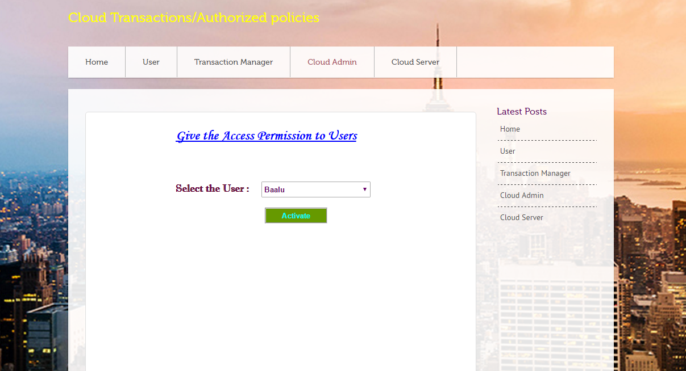

After Login into Admin Page

* 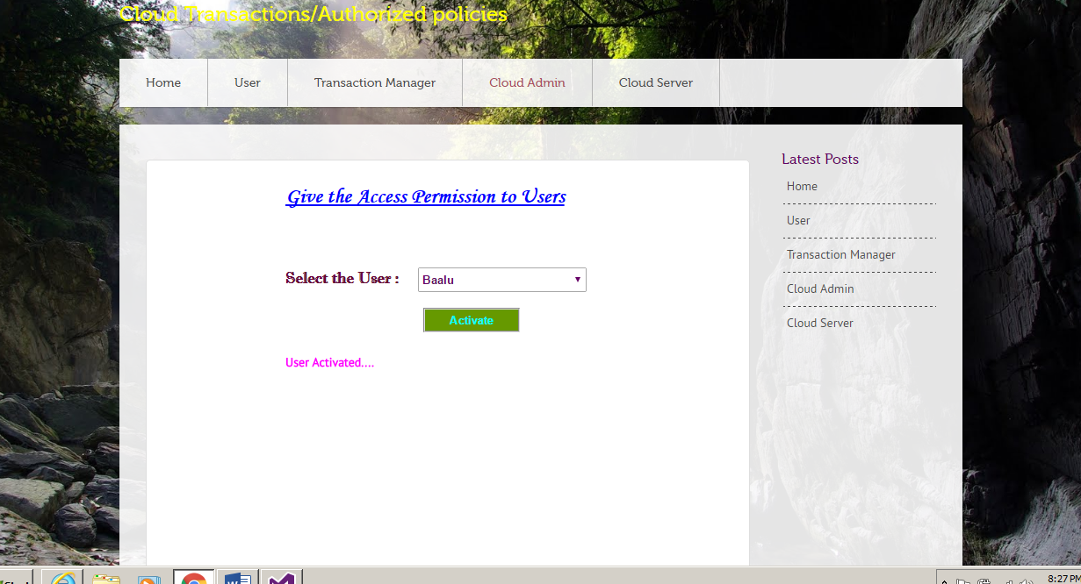

Admin Gives Access to the User

* 

User Activated

* 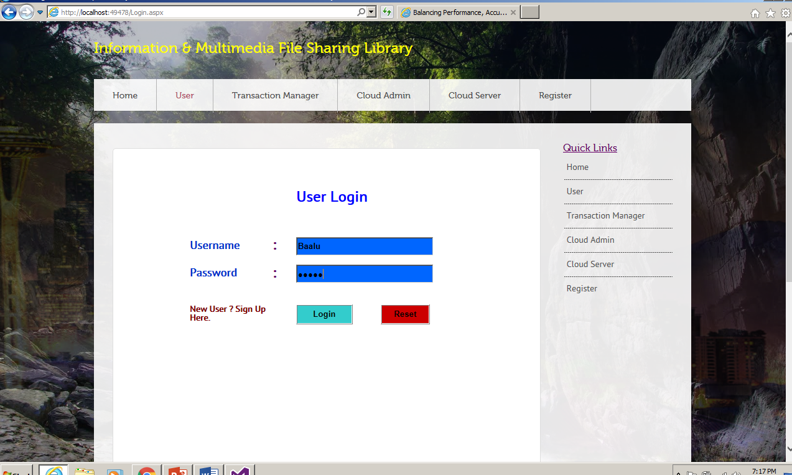

User Login in After given Authorization

* 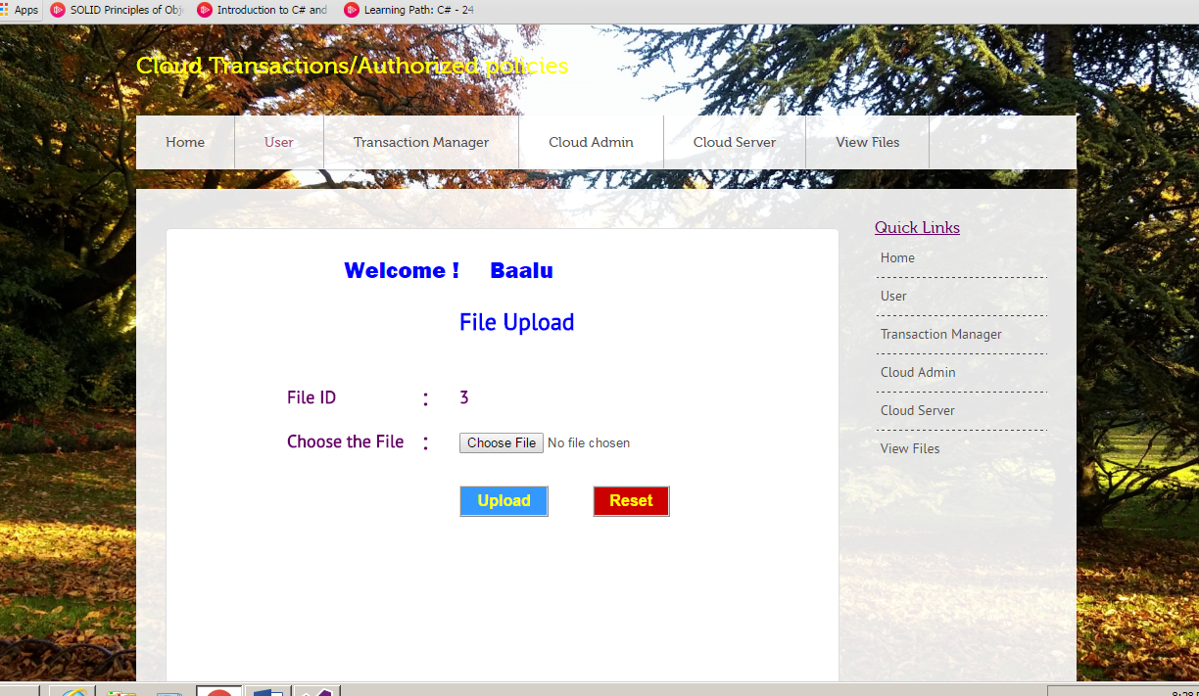

Welcome User Please Upload Page

* 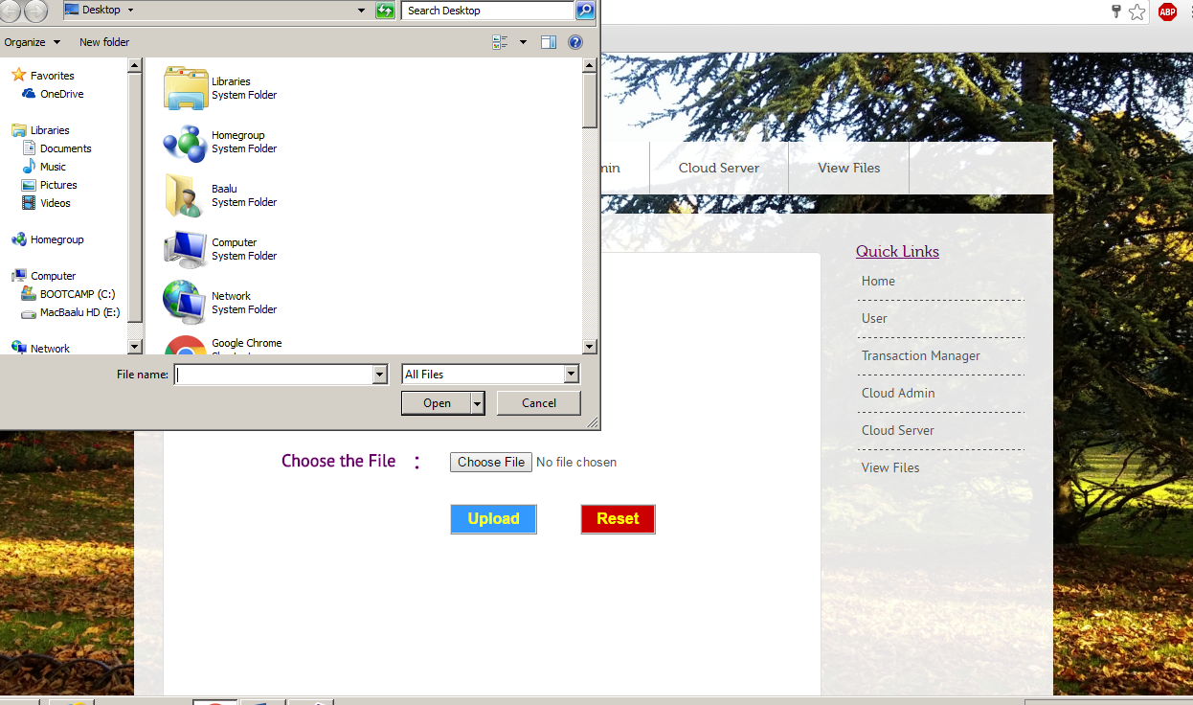

User choosing a file from Desktop to Upload

* 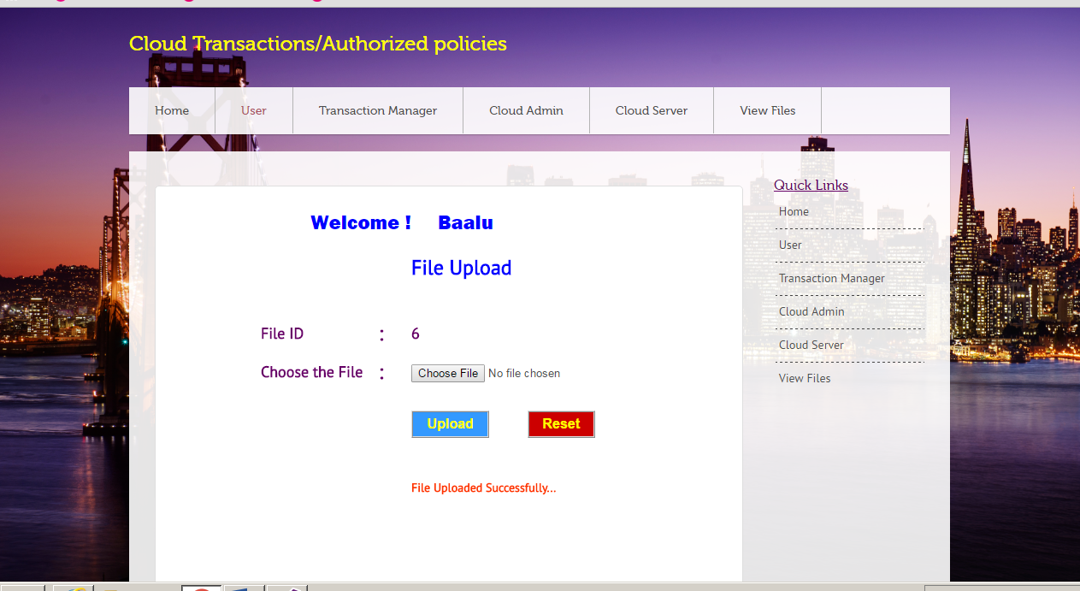

File Uploaded Successfully by the User

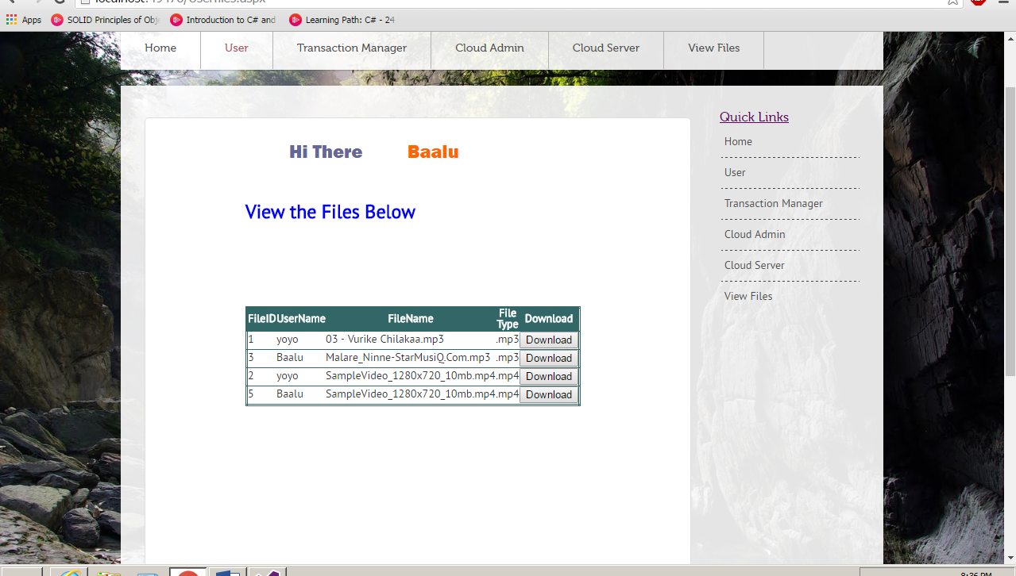

User Viewing the Files Uploaded After getting verification from the Server and Transaction Manager

* 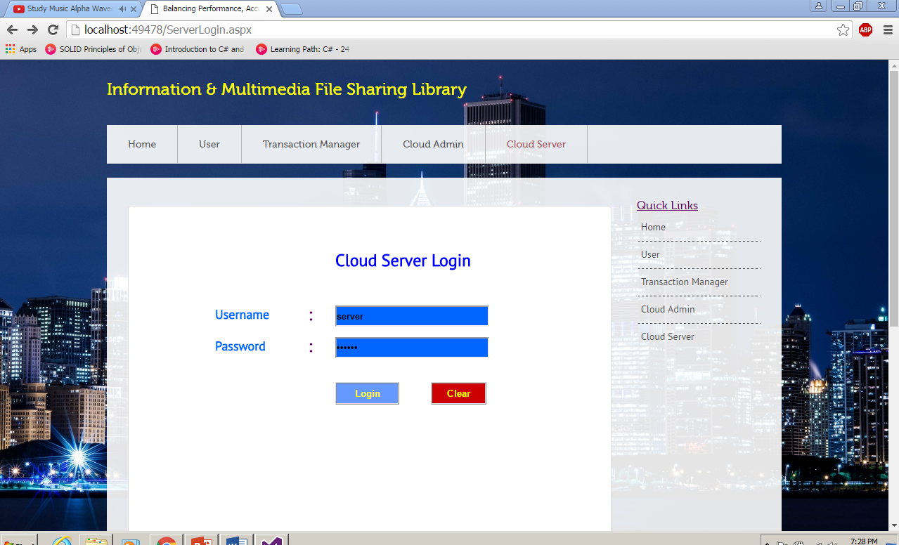

Cloud Admin login into the C Server Page

* 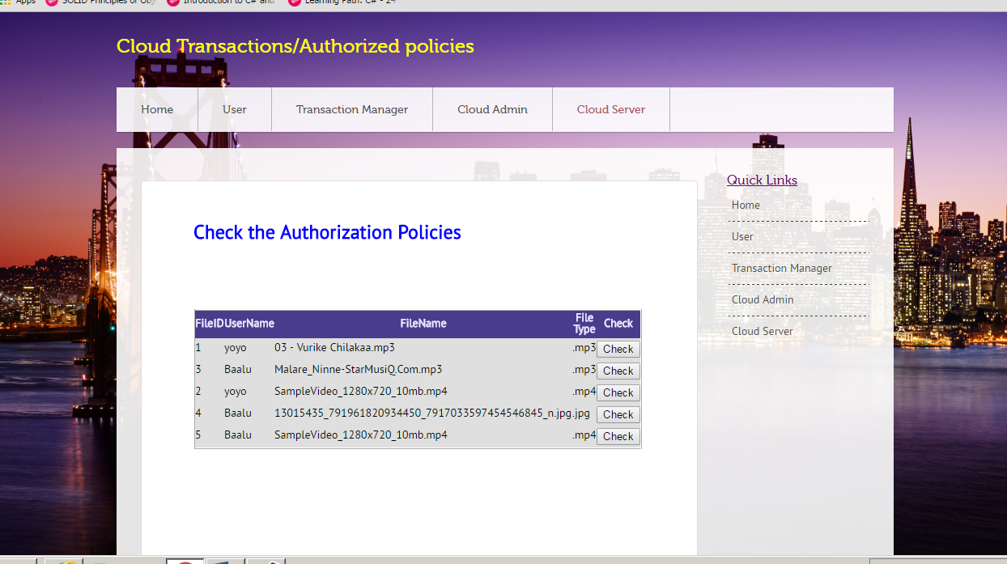

After Login into the Server Page the Admin Checks the Authorization Policies

* 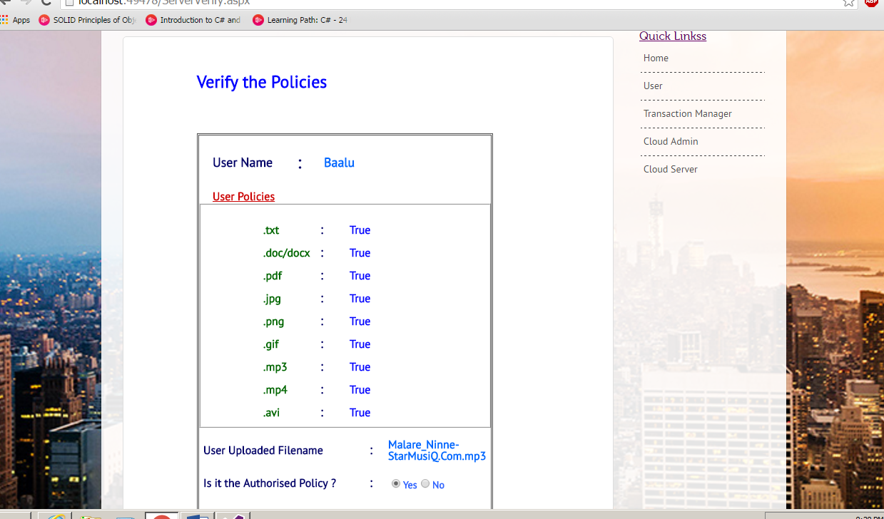

Verifying the Policies and allowing the Uploaded file

* 

Verified Successfully

* 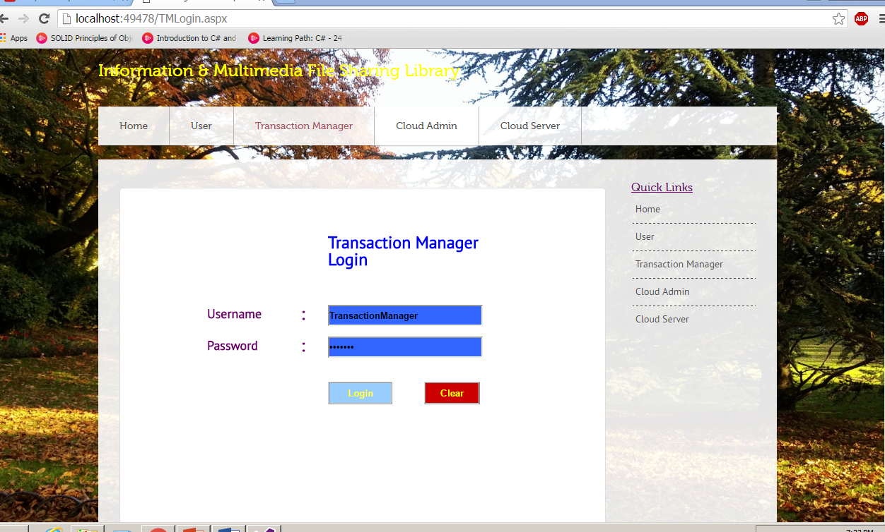

Transaction Manager Login into His Page

* 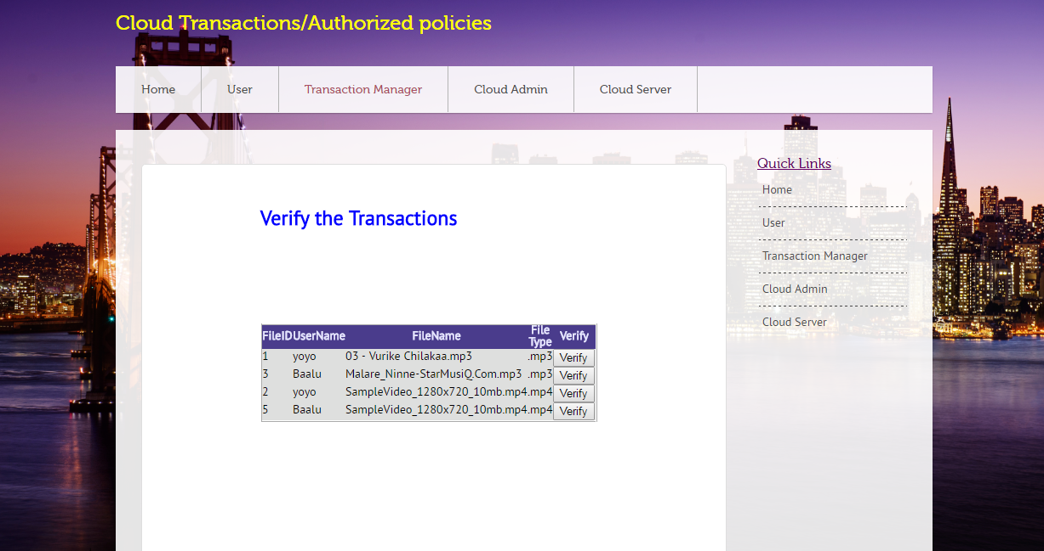

Verification of Transactions done by Transaction Manager

* 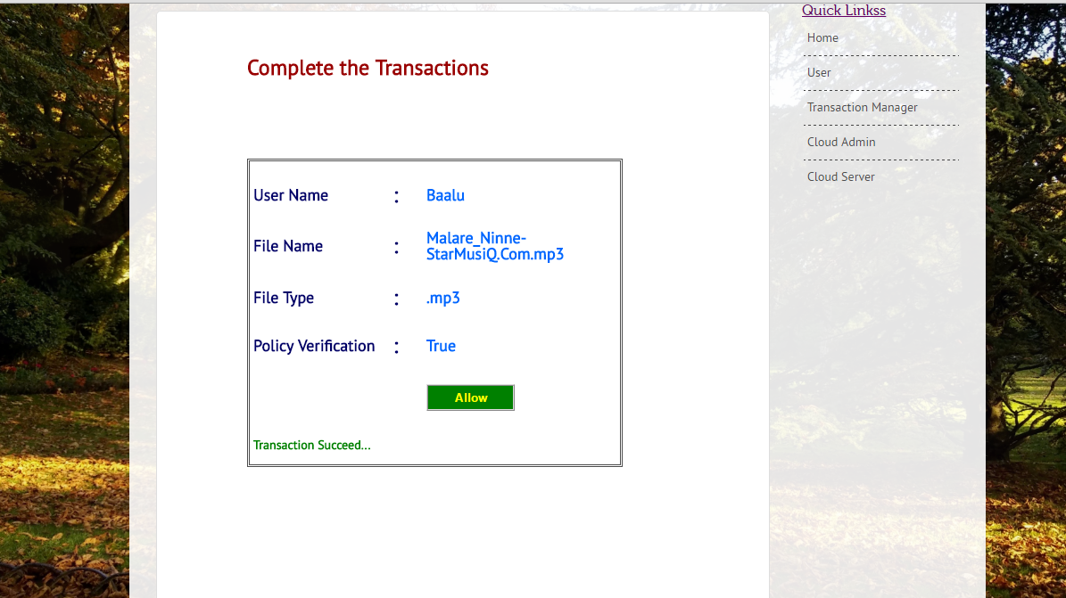

The Transaction Manager Allows the file and completes the transaction.

* 

Transaction successful

* 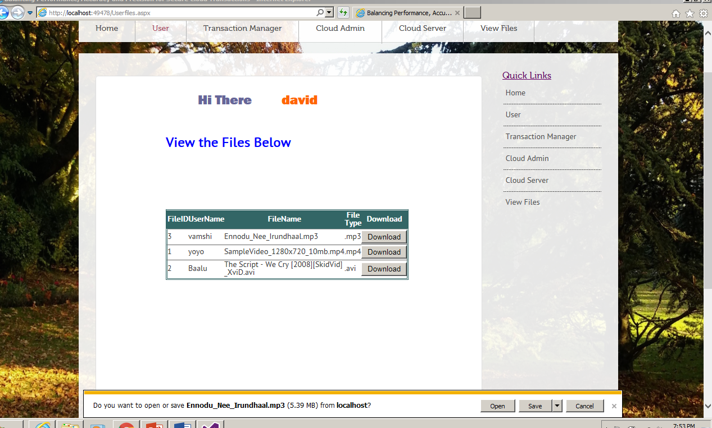

User Downloading Approved File

* 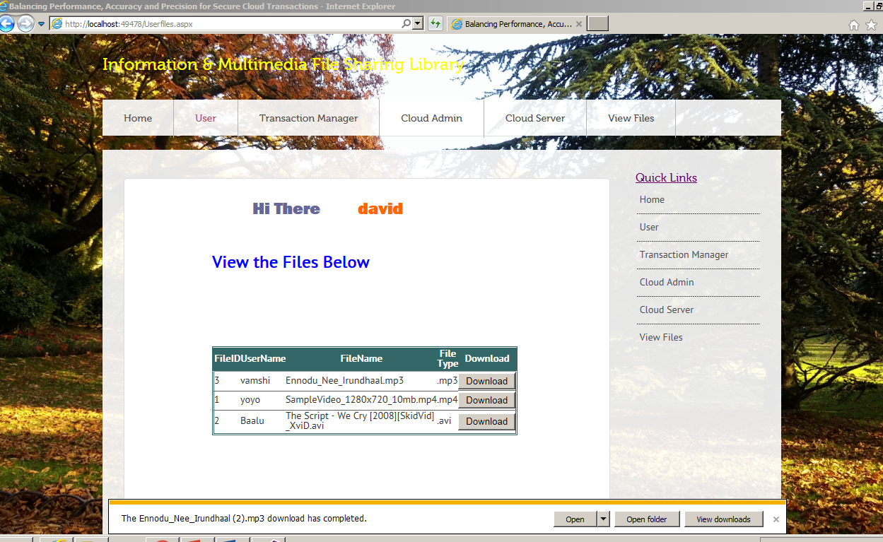

After saving the Downloaded File

* 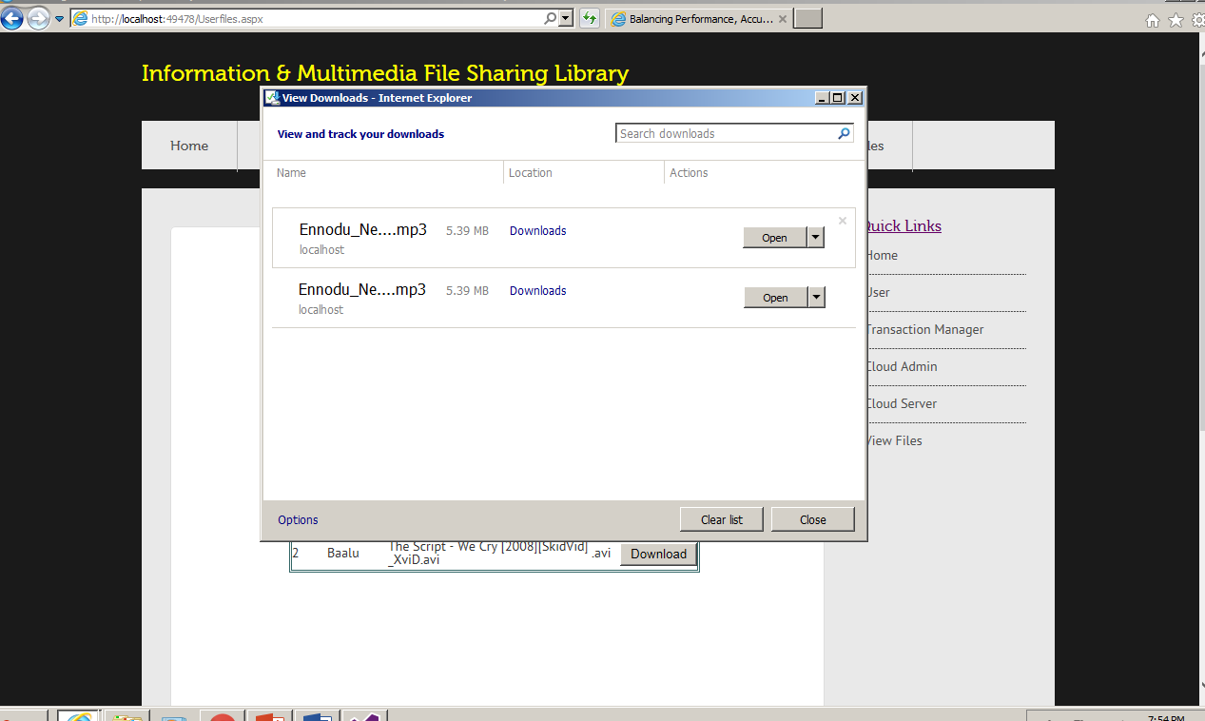

Downloaded file in the folder

# **Conclusion**

Instead of the popularity of cloud functionalities and their wide intake by enterprises and governments, cloud organizers still lack services that ensure both data and accessibility control policy constant across multiple data centers. In the current paper, we identified several consistency problems that can increase during hosted-cloud transaction processing using less consistency models, mainly if policy-based authorization systems are used to enforce access tools. I built up an assortment of lightweight verification requirement and consistency models for example, Deferred, Punctual, Incremental, and Continuous confirmations, with perspective or worldwide consistency—that can uphold progressively solid securities with insignificant runtime overheads. We utilized mimicked workloads to tentatively assess executions of our proposed consistency models with respect to three center measurements: exchange preparing execution, exactness and accuracy. We found that superior includes some significant downfalls: Deferred and Punctual verifications had negligible overheads, yet neglected to identify certain sorts of consistency issues. Then again, high-exactness models (i.e., Incremental and Continuous) required higher code many-sided quality to actualize accurately, and had just direct execution when contrasted with the lower precision plans. To better investigate the contrasts between these methodologies, we additionally completed a tradeoff examination of our plans to outline how application-driven necessities impact the materialness of the eight convention variations investigated in this paper.

# **Bibliography**

[1] M. Armbrust et al., “Above the Clouds: A Berkeley View of Cloud Computing,” technical report, Univ. of California, Feb. 2009.

[2] S. Das, D. Agrawal, and A.E. Abbadi, “Elastras: An Elastic Transactional Data Store in the Cloud,” Proc. Conf. Hot Topics in Cloud Computing (USENIX HotCloud ’09), 2009.

[3] D.J. Abadi, “Data Management in the Cloud: Limitations and Opportunities,” IEEE Data Eng. Bull., vol. 32, no. 1, pp. 3-12, Mar. 2009.

[4] A.J. Lee and M. Winslett, “Safety and Consistency in Policy-Based Authorization Systems,” Proc. 13th ACM Conf. Computer and Comm. Security (CCS ’06), 2006.

[5] M. Myers, R. Ankney, A. Malpani, S. Galperin, and C. Adams, “X.509 Internet Public Key Infrastructure Online Certificate Status Protocol - Ocsp,” RFC 2560, <http://tools.ietf.org/html/rfc5280>, June 1999.

[6] E. Rissanen, “Extensible Access Control Markup Language (Xacml) Version 3.0,” http://docs.oasis-open.org/xacml/3.0/ xacml-3.0-core-spec-os-en.html, Jan. 2013.

[7] D. Cooper et al., “Internet x.509 Public Key Infrastructure Certificate and Certificate Revocation List (CRL) Profile,” RFC 5280, http://tools.ietf.org/html/rfc5280, May 2008.

[8] J. Li, N. Li, and W.H. Winsborough, “Automated Trust Negotiation Using Cryptographic Credentials,” Proc. 12th ACM Conf. Computer and Comm. Security (CCS ’05), Nov. 2005.

[9] L. Bauer et al., “Distributed Proving in Access-Control Systems,” Proc. IEEE Symp. Security and Privacy, May 2005.

[10] J. Li and N. Li, “OACerts: Oblivious Attribute Based Certificates,” IEEE Trans. Dependable and Secure Computing, vol. 3, no. 4, pp. 340-352, Oct.-Dec. 2006.

[11] J. Camenisch and A. Lysyanskaya, “An Efficient System for Non-Transferable Anonymous Credentials with Optional Anonymity Revocation,” Proc. Int’l Conf. Theory and Application of Cryptographic Techniques: Advances in Cryptology (EUROCRYPT ’01), 2001.

[12] P.K. Chrysanthis, G. Samaras, and Y.J. Al-Houmaily, “Recovery and Performance of Atomic Commit Processing in Distributed Database Systems,” Recovery Mechanisms in Database Systems, Prentice Hall PTR, 1998.

[13] M.K. Iskander, D.W. Wilkinson, A.J. Lee, and P.K. Chrysanthis, “Enforcing Policy and Data Consistency of Cloud Transactions,” Proc. IEEE Second Int’l Workshop Security and Privacy in Cloud Computing (ICDCS-SPCCICDCS-SPCC), 2011.

[14] G. DeCandia et al., “Dynamo: Amazons Highly Available Key-Value Store,” Proc. 21st ACM SIGOPS Symp. Operating Systems Principles (SOSP ’07), 2007.

[15] F. Chang et al., “Bigtable: A Distributed Storage System for Structured Data,” Proc. Seventh USENIX Symp. Operating System Design and Implementation (OSDI ’06), 2006.

[16] A. Lakshman and P. Malik, “Cassandra- A Decentralized Structured Storage System,” ACM SIGOPS Operating Systems Rev., vol. 44, pp. 35-40, Apr. 2010.

[17] B.F. Cooper et al., “PNUTS: Yahoo!’s Hosted Data Serving Platform,” Proc. VLDB Endowment, vol. 1, pp. 1277-1288, Aug. 2008.

[18] W. Vogels, “Eventually Consistent,” Comm. ACM, vol. 52, pp. 40-44, Jan. 2009.

[19] H. Guo, P.-A. Larson, R. Ramakrishnan, and J. Goldstein, “Relaxed Currency and Consistency: How to Say “Good Enough” in SQL,” Proc. ACM Int’l Conf. Management of Data (SIGMOD ’04), 2004.

[20] T. Kraska, M. Hentschel, G. Alonso, and D. Kossmann, “Consistency Rationing in the Cloud: Pay Only When It Matters,” Proc. VLDB Endowment, vol. 2, pp. 253-264, Aug. 2009.

[21] G. Ateniese, R. Burns, R. Curtmola, J. Herring, L. Kissner, Z. Peterson, and D. Song, “Provable Data Possession at Untrusted Stores,” Proc. 14th ACM Conf. Computer and Comm. Security (CCS ’07), 2007.

# **Appendix**

**Sample Code**

**Ca Login**

public partial class CAlogin : System.Web.UI.Page

{

protected void Page_Load(object sender, EventArgs e)

{

}

protected void Button2_Click(object sender, EventArgs e)

{

TextBox1.Text = "";

TextBox2.Text = "";

}

protected void Button1_Click(object sender, EventArgs e)

{

if (TextBox1.Text.ToLower() == "ca" && TextBox2.Text.ToLower() == "ca")

{

Response.Redirect("CAuser.aspx");

}

else

{

Label6.Text = "InCorrect Details...";

}

}

}

**File Upload**

public partial class _Default : System.Web.UI.Page

{

SqlConnection con = new SqlConnection(ConfigurationManager.ConnectionStrings["BalancingCon"].ConnectionString);

protected void Page_Load(object sender, EventArgs e)

{

}

protected void Button1_Click(object sender, EventArgs e)

{

string usernm = DropDownList1.SelectedItem.ToString();

if (usernm != "")

{

con.Open();

SqlCommand cmd = new SqlCommand("update Register set LoginAccess = 'YES' where Username = '" + usernm + "'", con);

cmd.ExecuteNonQuery();

con.Close();

Label3.Text = "User Activated....";

}

}

}